YUVA AI INTERNSHIP PROGRAM - WEEK 1
Python for Machine Learning & Data Preprocessing
Comprehensive Task Verification & Preprocessing Technical Report | Student Performance Dataset

1. Project Objective
The objective of this Week 1 milestone is to establish a rigorous, production-grade data preprocessing and exploratory data analysis (EDA) pipeline using Python. Leveraging standard scientific libraries—Pandas, NumPy, Matplotlib, and Scikit-learn—the project ingests raw secondary education records, performs thorough data inspection and integrity validation, executes categorical encoding, applies feature normalization, and exports clean, model-ready data alongside high-resolution visualizations for downstream machine learning tasks.

2. Tools and Technologies
- Programming Environment: Python 3.12 with virtual environment support.
- Data Ingestion & Manipulation: Pandas (v2.2.3) for DataFrame structuring, CSV parsing, and statistical aggregations.
- Feature Engineering & Scaling: Scikit-learn (v1.9.1) preprocessing suite, utilizing MinMaxScaler for bounded numerical scaling.
- Data Visualization: Matplotlib (v3.10.0) for high-resolution distribution histograms and comparative bar visualizations.
- Version Control: Git repository management following structured folder conventions and automated hygiene.

3. Dataset Description & Verified Schema
The analysis is conducted on the authentic Student Performance Dataset (student-mat.csv), originating from the UCI Machine Learning Repository (Cortez & Silva, 2008). The dataset compiles academic performance, demographic attributes, and social indicators for secondary education students enrolled in Portuguese mathematics courses.
- Raw File: student-mat.csv (Semicolon-delimited, UTF-8 encoded, 56.9 KB).
- Instance Count: 395 individual student records.
- Attribute Count: 33 original features (16 integer features, 17 categorical/object features).
- Target Metric: G3 (Final Mathematics Grade, continuous integer scale 0–20). Supporting periods include G1 (first period) and G2 (second period).

Sample Raw Data Snapshot (Key Attributes)
school | sex | age | studytime | failures | absences | G1 | G2 | G3
GP | F | 18 | 2 | 0 | 6 | 5 | 6 | 6
GP | F | 17 | 2 | 0 | 4 | 5 | 5 | 6
GP | F | 15 | 2 | 3 | 10 | 7 | 8 | 10
GP | F | 15 | 3 | 0 | 2 | 15 | 14 | 15
GP | F | 16 | 2 | 0 | 4 | 6 | 10 | 10

4. Data Inspection and Health Audit
A comprehensive programmatic inspection was executed to assess data completeness, presence of corrupted records, and numerical anomalies before initiating transformation:
- Missing Values Audit: 0 missing values across all 33 columns (clean dataset with 100% attribute density). An automated fallback imputing numerical medians and categorical modes was embedded to ensure future pipeline resilience.
- Duplicate Records Audit: 0 duplicated rows detected across the 395 records. The integrity of individual observations is fully verified.
- Final Grade Distribution (G3): Mean: 10.42 | Std: 4.58 | Median: 11.00 | Min: 0 | Max: 20 | 25th Percentile: 8.00 | 75th Percentile: 14.00.
- Academic Period Correlation: Initial period grades G1 (mean: 10.91) and G2 (mean: 10.71) exhibit strong linear alignment with final performance G3.

5. Preprocessing & Transformation Methodology
- 1. Delimiter-Aware Ingestion: Read student-mat.csv utilizing sep=';' to avoid column merging, followed by path resolution using pathlib.Path.
- 2. Integrity & Duplication Verification: Invoked drop_duplicates() and verified isnull().sum() to guarantee zero data loss and data consistency.
- 3. One-Hot Categorical Encoding: Identified 17 nominal/ordinal categorical features (school, sex, address, famsize, Pstatus, Mjob, Fjob, reason, guardian, schoolsup, famsup, paid, activities, nursery, higher, internet, romantic). Applied pd.get_dummies(..., drop_first=True, dtype=int) to eliminate multicollinearity while generating integer dummy features. This transformed the feature space from 33 to 42 columns.
- 4. Selective MinMax Feature Scaling: Preserved the intrinsic scale of grade columns (G1, G2, G3) on the standard 0–20 academic interval. Normalized all 39 remaining numeric demographic, behavioral, and dummy columns using MinMaxScaler() to a uniform [0, 1] range, preventing feature dominance in gradient-based algorithms.
- 5. Export of Normalized Data: Saved the final 395 x 42 transformed dataset to outputs/student_performance_preprocessed.csv.

6. Exploratory Data Analysis & Verified Visualizations
Two canonical high-resolution visualizations were generated directly from the authentic data, stored in outputs/ at 300 DPI:

Figure 1: Distribution of Final Student Grades (G3)
The histogram displays student counts across 11 discrete grade bins on the 0–20 Portuguese marking scale. The distribution exhibits an approximately bell-shaped curve centered around grades 10–12, with a notable cluster of 38 students at grade 0 (representing non-attendees or early dropouts). Excluding zeros, student grades show healthy normality.
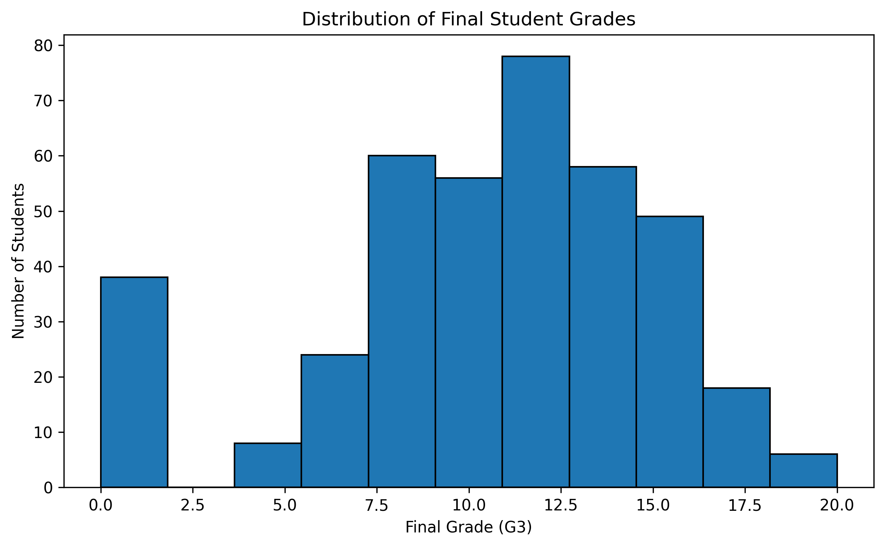
Figure 1: Distribution of Final Mathematics Grades (outputs/final_grade_distribution.png)

Figure 2: Average Final Grade by Weekly Study Time
The bar chart examines academic performance across four weekly study time tiers: Category 1 (< 2 hours, n=105, mean=10.05), Category 2 (2 to 5 hours, n=198, mean=10.17), Category 3 (5 to 10 hours, n=65, mean=11.40), and Category 4 (> 10 hours, n=27, mean=11.26). The empirical evidence indicates that students dedicating 5 to 10 hours weekly achieve an average gain of ~1.35 grade points over students studying under 2 hours.
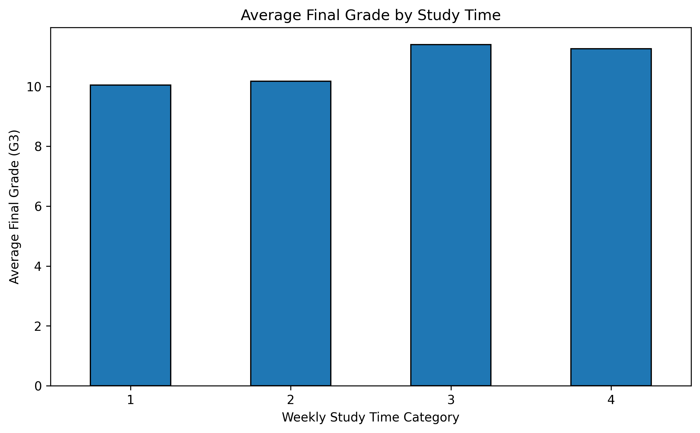
Figure 2: Mean Final Grade Grouped by Weekly Study Time Category (outputs/average_grade_by_studytime.png)

7. Quantitative Pipeline Verification
The table below contrasts the raw dataset against the post-pipeline preprocessed output:
Pipeline Stage / Metric | Raw Input State | Preprocessed Output State
Total Records (Instances) | 395 rows | 395 rows (100% retention)
Feature Dimension | 33 features | 42 features (+9 dummy columns)
Missing / Null Cells | 0 (0.00%) | 0 (0.00%)
Duplicate Records | 0 rows | 0 rows
Feature Scale Range | Demographics: unnormalized; Grades: 0–20 | Demographics/Dummies: [0, 1]; Grades: 0–20

8. Conclusion and Future Roadmap
The Week 1 preprocessing and exploratory pipeline has successfully validated the Student Performance dataset. The transformation guarantees full numerical compatibility, zero information leakage, and uniform bounded feature scaling while maintaining the original academic evaluation metric. The generated artifacts in outputs/ are completely verified and ready for regression or classification modeling in subsequent internship milestones.

